**Project Design Phase-I**

**Solution Architecture**

|  |  |
| --- | --- |
| Date | 13 May 2023 |
| Team ID | NM2023TMID14694 |
| Project Name | Advanced breast cancer prediction with deep learning |

**Solution Architecture:**

Solution architecture is a complex process – with many sub-processes – that bridges the gap between business problems and technology solutions. Its goals are to:

* Find the best tech solution to solve existing business problems.
* Describe the structure, characteristics, behavior, and other aspects of the software to project stakeholders.
* Define features, development phases, and solution requirements.
* Provide specifications according to which the solution is defined, managed, and delivered.

**Example - Solution Architecture Diagram**

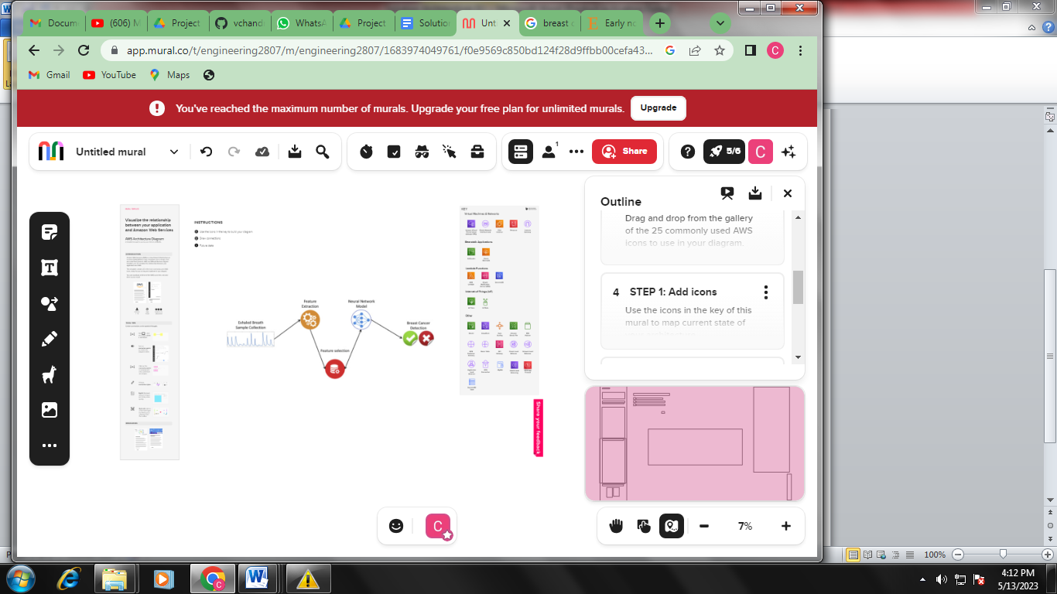

**Reference:**

**https://app.mural.co/t/engineering2807/m/engineering2807/1683974049761/f0e9569c850bd124f28d9ffbb00cefa43257bf82?sender=u7c4b0413dcf8e679b3a90729**